Owncloud: Quick Installation Guide, Release 10.0.10

First Released Date: 17.08.2018

Contents

Owncloud: Quick Installation Guide, Release 10.0.10 1

First Released Date: 17.08.2018 1

1. Introduction 3

2. Overview 4

3. About this Guide 5

4. Assumptions 6

5. Quick Deployment 7

General References 7

6. What’s New in ownCloud 10.0.10 8

7. File syncing and Owncloud Clients: Calendars and Contacts 9

**Synchronizing calendars with CalDAV** 9

**Synchronising contacts with CardDAV** 12

8. External Storage 14

Storage Configuration 14

**User and Group Permissions** 15

9. Files and Synchronisation 16

10. The Web Interface 17

11. Install Owncloud 9 18

Installing OwnCloud On Ubuntu 17.04 / 17.10 With Apache2, MariaDB And PHP 18

## Introduction

Owncloud helps you to operate, organize, and retrieve the applications online. It is the direct way to file synchronisation and share data.  We need not to install a piece of software on our local PC and this is how, the cloud computing overcomes platform dependency issues. Thus makes our business application mobile and collective.

With Owncloud you can access your data anytime, anywhere.

OwnCloud is hosted exclusively on your own private server or cloud so that it is guaranteed that your data is under your control. It is all about your privacy. Owncloud protects your files. Only you can manage your files.

## Overview

Owncloud is Open Source file sharing solution for enterprises of any size with more than 25 million users. Around 200.000 installations across the globe is available in various versions.

You can share one or more files and folders on your computer, and synchronize them with your ownCloud server. Place files in your local shared directories, and those files are immediately synchronized to the server and to other devices using the ownCloud Desktop Sync Client, Android app, or iOS app. To learn more about the ownCloud desktop and mobile clients, please refer to their respective manuals:

* [ownCloud Desktop Client](https://doc.owncloud.org/desktop/latest/)
* [ownCloud Android App](https://doc.owncloud.org/android/)
* [ownCloud iOS App](https://doc.owncloud.org/ios/)

## About this Guide

This guide has been created in order to help developers, product managers, network specialists, and Sales and Marketing personnel. It provides guidelines on how you can share multiple files and folders on your computer, and synchronize them with your OwnCloud server. It gives you a better understanding about how to distribute your files at various locations and those files are immediately synchronized to the server. Even in a multiuser interface, OwnCloud is very user-friendly. You can easily access all your stored data in collaborative files and track its details about its locations and which members of the interface have a virtual easement to these data figures.

This guide is for users who want to install and administer their OwnCloud servers. You can learn more about the ownCloud Web user interface, and desktop and mobile clients in this guide

## Assumptions

**OwnCloud** officially requires a **minimum** of 128 MB RAM. But, we recommend a **storage availability** of 512MB. Scanning of files is committed internally in 10k files chunks. Based on tests, server memory usage for scanning greater than 10k files uses about 75MB of surplus memory.

Enterprise-grade Linux distribution with full support from an operating system vendor. Both RedHat Enterprise Linux and SUSE Linux Enterprise Server 12 are recommended.

To use Owncloud at its maximum efficiency you will require the following:

* Centos Linux 6 and 7
* Debian 7 and 8
* Fedora 27 and 28
* Red Hat Enterprise Linux 6 and 7
* SUSE Linux Enterprise Server 12 with SP1, SP2 and SP3
* openSUSE Tumbleweed and Leap 15.0, 42.3
* Ubuntu 16.04 and 18.04
* MySQL, Oracle, PostgreSQL or SQLite
* Apache 2.4
* PHP 7.2

## Quick Deployment

Every ownCloud customer has their own particular requirements. They have their own IT infrastructure as well. However, you can configure Owncloud according to your requirements.

## General References

* 2 to 4 application servers.
* A cluster of two database servers.
* Storage on an NFS server.
* Authentication via an existing LDAP or Active Directory server.
* Operating system: Linux.
* Web server: Apache 2.4.
* Database: MySQL/MariaDB with InnoDB storage engine PHP 7.2.
* OwnCloud Administrators must have Command Line.
* One machine running the application, web, and database server, as well as local storage. Authentication via an existing LDAP or Active Directory server.
* The SSL termination is done in Apache. A standard SSL certificate is required to be installed

## What’s New in ownCloud 10.0.10

1. Option to hide or expose hidden files in the Web GUI
2. It is necessary for you to use at least desktop client version 2.0 by default.

## File syncing and Owncloud Clients: Calendars and Contacts

It can be difficult if you want to keep all of your calendars and contacts up to date, if you have a laptop at home, a desktop at work, and have a smartphone. OwnCloud has an efficient way of doing this so that you do not have to depend on Google calendars and Google contacts to manage your personal information system.

OwnCloud uses the web standards (CalDAV/ CardDAV) to become up-to-date always. They are open standards and are used by many applications to send and receive data to keep everything in sync.

A quick search on the web will reveal a lot of different CalDAV and CardDAV personal information managers to choose from. The popular email client Thunderbird as it can work across multiple types of platforms or operating environments and works with both CalDAV and CardDAV.

## **Synchronizing calendars with CalDAV**

Install the latest version of Thunderbird from <http://www.mozilla.org/thunderbird/>

Then install the latest version of Lightning and the Sogo Connector plugin for Thunderbird from this address <http://www.sogo.nu/english/downloads/frontends.html>. These plugins give you the ability to add a remote calendar and address book to Thunderbird. You may need to restart Thunderbird to see your calendar.

1. Activate your Thunderbird calendar by selecting ***Events and Tasks > Calendar Book***.    
     
   Now select ***File > New > Calendar***.

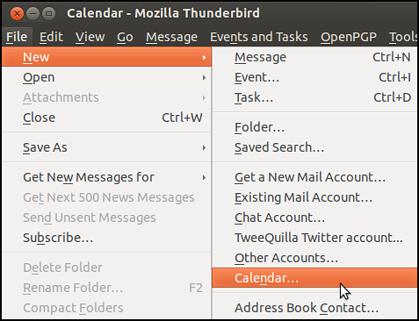

1. Select ***On the Network***.

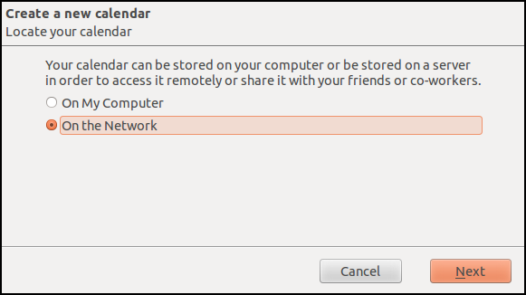

1. Then enter the ***CalDAV Link*** URL of the chosen calendar from ownCloud.

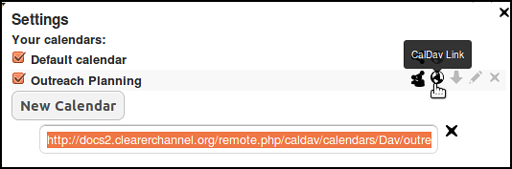

1. Click the globe in your calendar settings to get the right link.

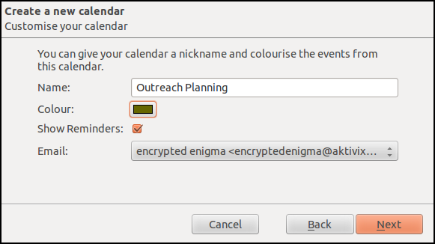

1. Give the calendar a name and select a color.  Then link it with your email.

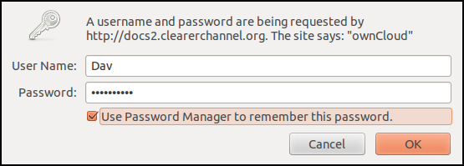

1. Insert the ***User Name*** and ***Password*** that you use for ownCloud and click ***OK***.

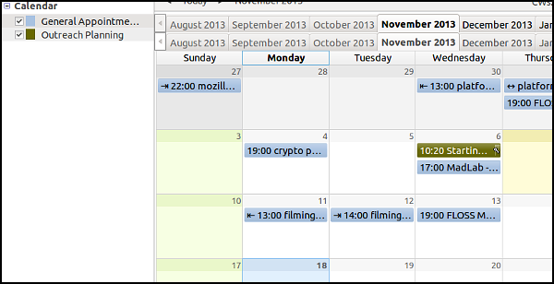

1. You can read and write to your calendar from inside Thunderbird. You can repeat this process with other remote calendars.

## **Synchronising contacts with CardDAV**

Install Thunderbird and Sogo Connector plugin as detailed in the section above. 

1. Activate your Thunderbird address book by selecting ***Tools > Address Book***.    
   Now select ***File > New > Remote Addressbook***.

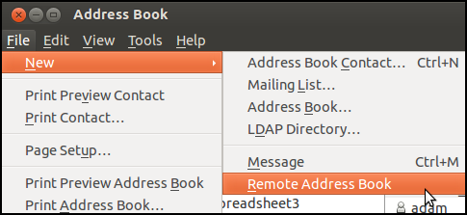

**Name:** Enter a name for your address book.

**URL:** Add the relevant CardDAV URL from your ownCloud ***Contacts*** area.

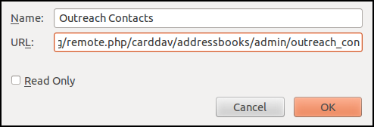

1. To find the URL, click on the settings component in the bottom left of your contacts area.

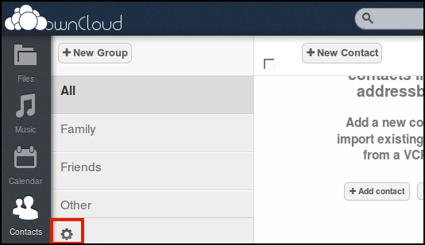

Each address book has it's own ***CardDAV link*** indicated by the globe icon.

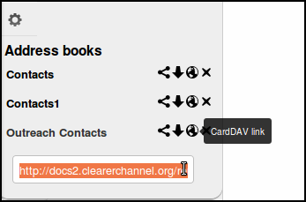

1. Back in Thunderbird, synchronize with the remote address book by right clicking select ***Synchronize***.

g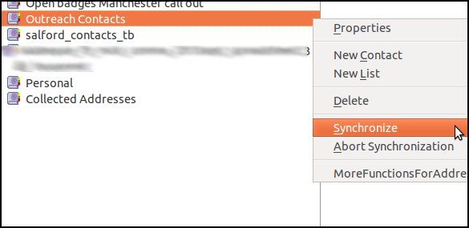

1. The local address book is populated with the contacts in ownCloud. Similarly, adding or editing your contacts in Thunderbird will trigger a sync with the ownCloud server.

## External Storage

The External Storage Support application helps you to mount external storage services and devices as secondary ownCloud storage devices. You can allow users to mount their own external storage services.

## Storage Configuration

To create a new external storage mount, select an available backend from the dropdown **Add storage**.

Each backend has different required options, which are configured in the configuration fields.

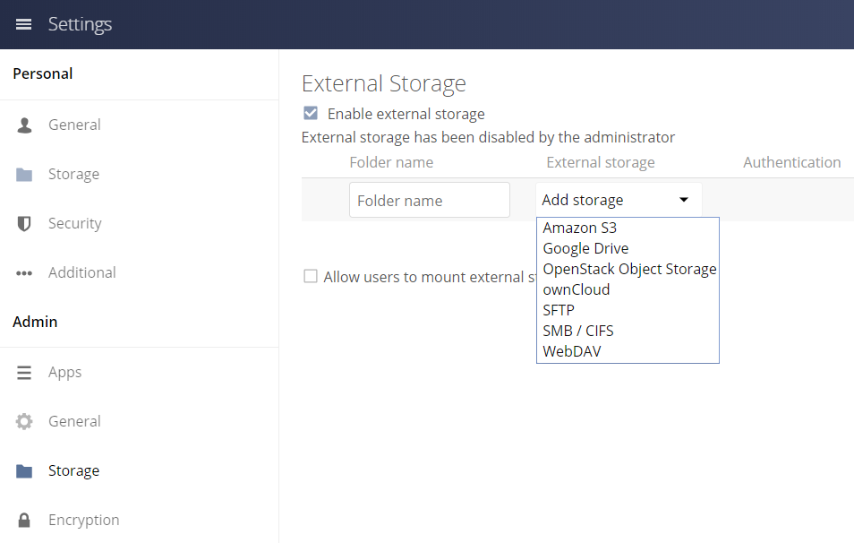

Each backend may also accept multiple authentication methods. These are selected with the dropdown under **Authentication**. Different backends support different authentication mechanisms; some specific to the backend, others are more generic.

When you select an authentication mechanism, the configuration fields change as appropriate for the mechanism. The SFTP backend, for one example, supports **username and password**, **Log-in credentials, save in session**, and **RSA public key**.

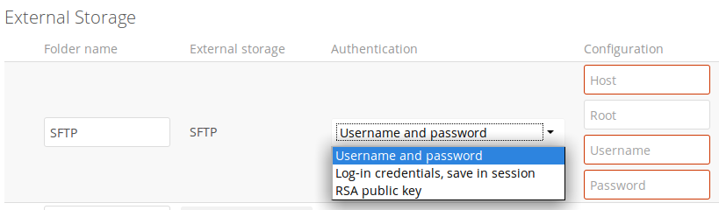

Required fields are marked and highlighted with a red border. When all required fields are filled, the storage is automatically saved. A green dot next to the storage row indicates the storage is ready for use.

In case you see a red or yellow icon, it indicates that ownCloud was not able to connect to the external storage, so you need to re-check your configuration and network availability.

If there is an error on the storage, it will be marked as unavailable for ten minutes. To re-check it, click the colored icon or reload your Admin page.

## **User and Group Permissions**

A storage configured in a user’s Personal settings is available only to the user that created it. A storage configured in the Admin settings is available to all users by default, and it can be restricted to specific users and groups in the **Available for** field.

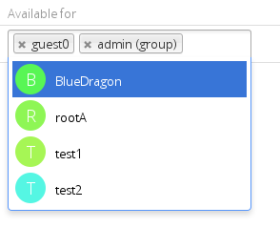

## Files and Synchronisation

OwnCloud fully supports the WebDAV protocol, and you can connect and synchronize with your ownCloud files over WebDAV. You will be able to connect to Linux, Mac OS X, Windows, and mobile devices to your ownCloud server via WebDAV.

OwnCloud Web interface opens to your Files page. You can add, remove, and share files, and make changes based on the access privileges set by you (if you are administering the server) or by your server administrator. You can configure the ownCloud client to save files in any local directory you want, and you choose which directories on the ownCloud server to sync with.

The client displays the current connection status and logs all activity, so you always know which remote files are being downloaded to your PC, and you can verify that files created and updated on your local PC are properly synchronized with the server.

If you prefer, you may also connect your desktop PC to your ownCloud server by using the WebDAV protocol instead of using another client application. Web Distributed Authoring and Versioning (WebDAV) is a Hypertext Transfer Protocol (HTTP) extension that makes it much easier to create, read, and edit files on Web servers. With WebDAV you can access your ownCloud shares on Linux, Mac OS X and Windows in the same way as any remote network share, and stay synchronized.

With Deltasync OwnCloud offers a technology that accelerates the synchronization of updated files. Instead of the complete file. The sync client only uploads or downloads the corresponding modified parts when files are modified. This significantly reduces the volume of transmitted data.

Refer the following options for files synchronisation:

* [Accessing ownCloud Files Using WebDAV](https://doc.owncloud.com/server/10.0/user_manual/files/access_webdav.html)
* [Using the ownCloud Web Interface](https://doc.owncloud.com/server/10.0/user_manual/files/webgui/index.html)
* [Public Link Shares](https://doc.owncloud.com/server/10.0/user_manual/files/public_link_shares.html)
* [Desktop and Mobile Synchronization](https://doc.owncloud.com/server/10.0/user_manual/files/desktop_mobile_sync.html)
* [Encrypting Your ownCloud Files](https://doc.owncloud.com/server/10.0/user_manual/files/encrypting_files.html)
* [Gallery App](https://doc.owncloud.com/server/10.0/user_manual/files/gallery_app.html)
* [Managing Deleted Files](https://doc.owncloud.com/server/10.0/user_manual/files/deleted_file_management.html)
* [Large File Uploads](https://doc.owncloud.com/server/10.0/user_manual/files/large_file_upload.html)
* [Troubleshooting](https://doc.owncloud.com/server/10.0/user_manual/files/troubleshooting.html)
* [Using Federation Shares](https://doc.owncloud.com/server/10.0/user_manual/files/federated_cloud_sharing.html)
* [Version Control](https://doc.owncloud.com/server/10.0/user_manual/files/version_control.html)

## The Web Interface

You are able connect to your ownCloud server using any Web browser; Enter your username and password. Supported Web browsers are:

* + Firefox 14+
  + Chrome 18+
  + Safari 5+
  + IE11+

**Navigating the Main User Interface**

The ownCloud Web interface opens to your Files page (default). You are able to add, remove, and share files, and make changes based on the access privileges set by you (if you are the administrator) or by your server administrator.

**[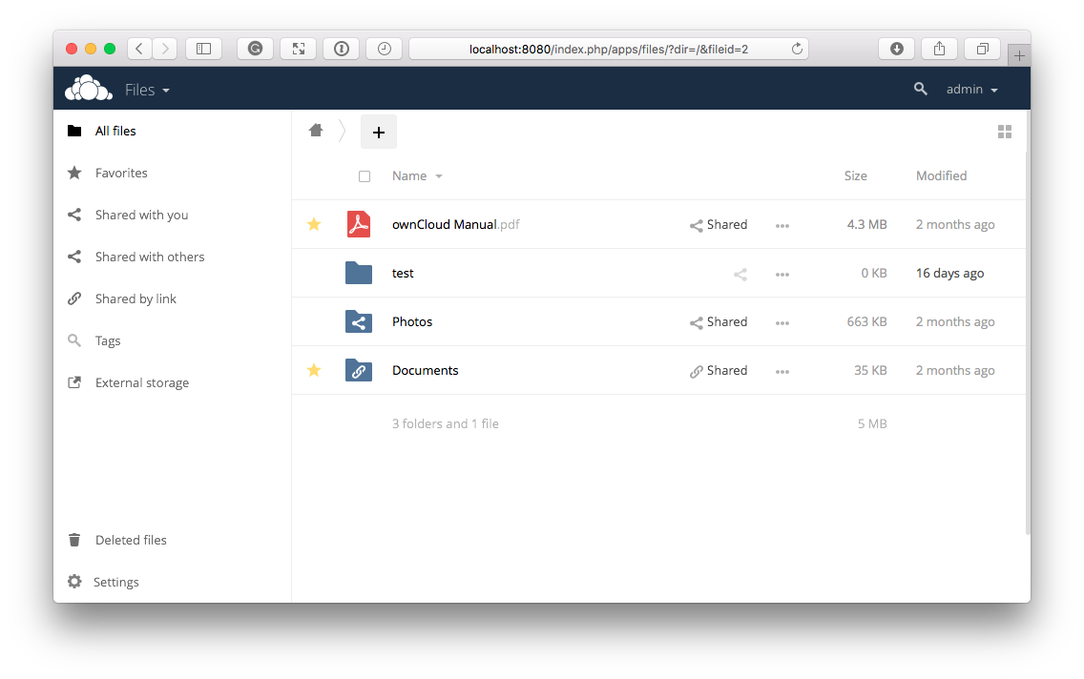](https://doc.owncloud.com/server/10.0/user_manual/_images/files_page1.png)**

## Install Owncloud 9

## Installing OwnCloud With Apache2, MariaDB And PHP

OwnCloud is an open source software. It permits private cloud services on users’ own servers(environments). Like any cloud storage services, OwnCloud provides similar functions, and it’s free to download and install on your own servers without remunerating service providers.

To get started with installing OwnCloud, follow the steps below:

#### **Step 1: Install Apache2**

OwnCloud requires a webserver to function. Install Apache2 on Ubuntu by running the commands below:

sudo apt install apache2

After installing Apache2, run the commands below to disable directory listing.

sudo sed -i "s/Options Indexes FollowSymLinks/Options FollowSymLinks/" /etc/apache2/apache2.conf

Next, run the commands below to stop, start and enable Apache2 service to always start up with the server boots.

sudo systemctl stop apache2.service

sudo systemctl start apache2.service

sudo systemctl enable apache2.service

#### **Step 2: Install MariaDB**

OwnCloud also requires a database server to function. Install MariaDB database. To install the same run the commands below.

sudo apt-get install mariadb-server mariadb-client

After installing, the commands below can be used to stop, start and enable MariaDB service to always start up when the server boots.

sudo systemctl stop mariadb.service

sudo systemctl start mariadb.service

sudo systemctl enable mariadb.service

After that, run the commands below to secure MariaDB server:

When prompted, answer the questions below by following the guide.

Restart MariaDB server

sudo systemctl restart mariadb.service

#### **Step 3: Install PHP And Related Modules**

OwnCloud also requires PHP to function. To install PHP and related modules run the commands below:

sudo apt install php libapache2-mod-php php-common libapache2-mod-php php-mbstring php-xmlrpc php-soap php-apcu php-smbclient php-ldap php- redis php-gd php-xml php-intl php-json php-imagick php-mysql php-cli php-mcrypt php-ldap php-zip php-curl

sudo apt install php libapache2-mod-php php-common libapache2-mod-php php-mbstring php-xmlrpc php-soap php-apcu php-smbclient php-ldap php- redis php-gd php-xml php-intl php-json php-imagick php-mysql php-cli php-mcrypt php-ldap php-zip php-curl

#### **Step 4: Create OwnCloud Database**

After installation of all the packages that are required, configure the servers. First run the commands below to create OwnCloud database. Run the commands below to logon to the database server. When prompted for a password, type the root password you created above.

sudo mysql -u root -p

Then create a database called **owncloud.**

CREATE DATABASE owncloud;

Create a database user called **ownclouduser** with new password

CREATE USER 'ownclouduser'@'localhost' IDENTIFIED BY 'new_password_here';

You can grant the user full access to the database.

GRANT ALL ON owncloud.* TO 'ownclouduser'@'localhost' IDENTIFIED BY 'user_password_here' WITH GRANT OPTION;

Finally, save your changes and exit.

FLUSH PRIVILEGES;

EXIT;

#### **Step 5: Download OwnCloud (Most RECENt Release)**

After downloading, run the commands below to extract the download file into Apache2 root directory.

cd /tmp && wget https://download.owncloud.org/community/owncloud-10.0.3.zip

unzip owncloud-10.0.3.zip

sudo mv owncloud /var/www/html/owncloud/

Then run the commands below to set the correct permissions for OwnCloud to function.

sudo chown -R www-data:www-data /var/www/html/owncloud/

sudo chmod -R 755 /var/www/html/owncloud/

#### **Step 6: Configure Apache2**

Configure Apahce2 site configuration file for OwnCloud. This file will control how users access OwnCloud content. Run the commands below to create a new configuration file called **owncloud.conf.**

sudo nano /etc/apache2/sites-available/owncloud.conf

Then copy and paste the content below into the file and save it. Replace the highlighted line with your own domain name and directory root location.

<VirtualHost *:80>

ServerAdmin admin@example.com

DocumentRoot /var/www/html/owncloud/

ServerName example.com

ServerAlias www.example.com

Alias /owncloud "/var/www/html/owncloud/"

<Directory /var/www/html/owncloud/>

Options +FollowSymlinks

AllowOverride All

Require all granted

<IfModule mod_dav.c>

Dav off

</IfModule>

SetEnv HOME /var/www/html/owncloud

SetEnv HTTP_HOME /var/www/html/owncloud

</Directory>

ErrorLog ${APACHE_LOG_DIR}/error.log

CustomLog ${APACHE_LOG_DIR}/access.log combined

</VirtualHost>

Save the file and exit.

#### **Step 7: Enable The OwnCloud And Rewrite Module**

After configuring the VirtualHost above, enable it by running the commands below:

sudo a2ensite owncloud.conf

sudo a2enmod rewrite

sudo a2enmod headers

sudo a2enmod env

sudo a2enmod dir

sudo a2enmod mime

#### **Step 8 : Restart Apache2**

To load all the settings above, restart Apache2 by running the commands below.

sudo systemctl restart apache2.service

Then open your browser and browse to the server domain name followed by install. You should see OwnCloud setup wizard to complete. Please follow the wizard carefully.